SUPERVISION
Date / time: 27/11/2025

Main issues discussed
- There is no need to worry too much about the word limit. The regulations do not specify any penalty for exceeding the word count, and if the work is of high quality with a reasonable justification, a longer length is acceptable.
- The project will be marked independently by two supervisors. They will first assess it without discussing it with each other, and then discuss it together to agree on a final grade.
- I showed and emailed my supervisor multiple documents. My supervisor advised me to significantly compress the content.
2. The main difficulty of the presentation (CW2) is that I conducted a large number of experiments, and the challenge is how to clearly explain all of them within 10 minutes. To achieve a good mark in the presentation, it is necessary to stay within the time limit. The requirement is 15 minutes in total, including a 10-minute project presentation and a 5-minute Q&A session. I need to speak more slowly and clearly. Some students have too many slides and therefore have to speak very quickly, which leads to poor presentation quality. I think six slides are sufficient for me because my speaking speed is not as fast as that of a native speaker, and my supervisor agreed with this.
3. Presentation arrangements with the second supervisor (Taylor Ring). My supervisor will try to arrange my presentation for Tuesday, 2 December. If there is not enough time, it will be postponed to a later date.
4. Some materials can be moved to the appendix, as it does not count towards the main word count. However, the main body must still be logical and coherent. Core content should not be placed in the appendix.

Work shown
- Draft for energy consumption measurement.
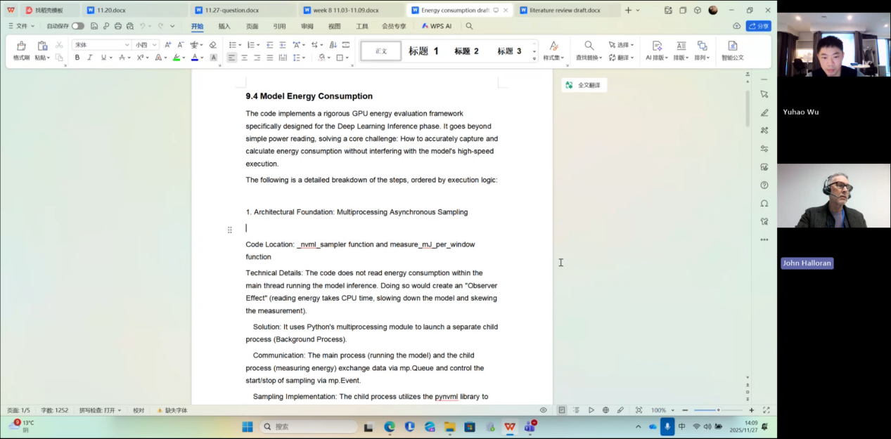

- Github code
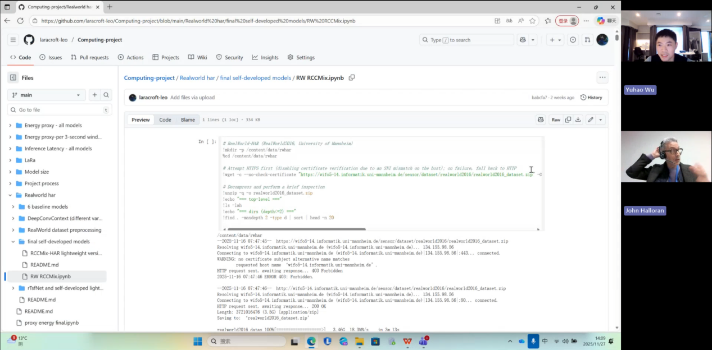

- Draft for Literature review
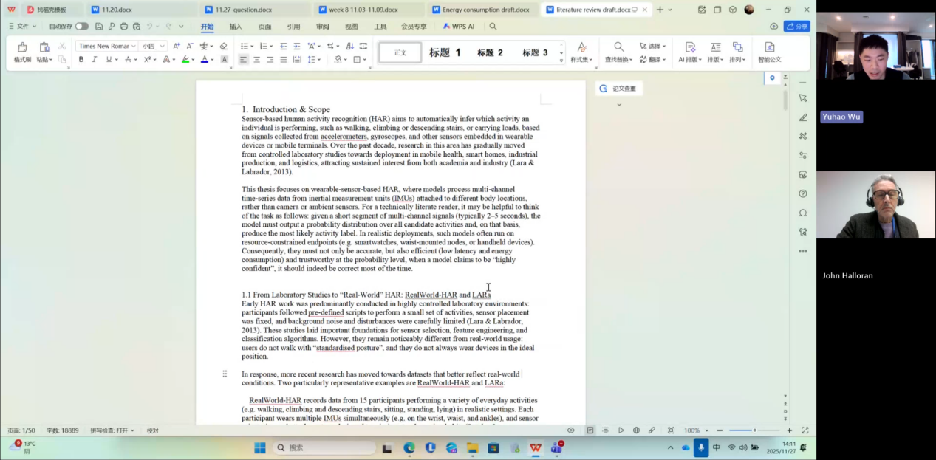
I emailed the documents shown above to my supervisor and revised them based on his feedback.

Questions asked; how questions were answered
My dissertation is currently 50,000 words long; is that too much?

Answer
50,000 words is indeed “a lot”, but if you truly did a lot of work, a large word count is natural. The key question is why it has become so long. I need to take a look before I can give you feedback.

Email
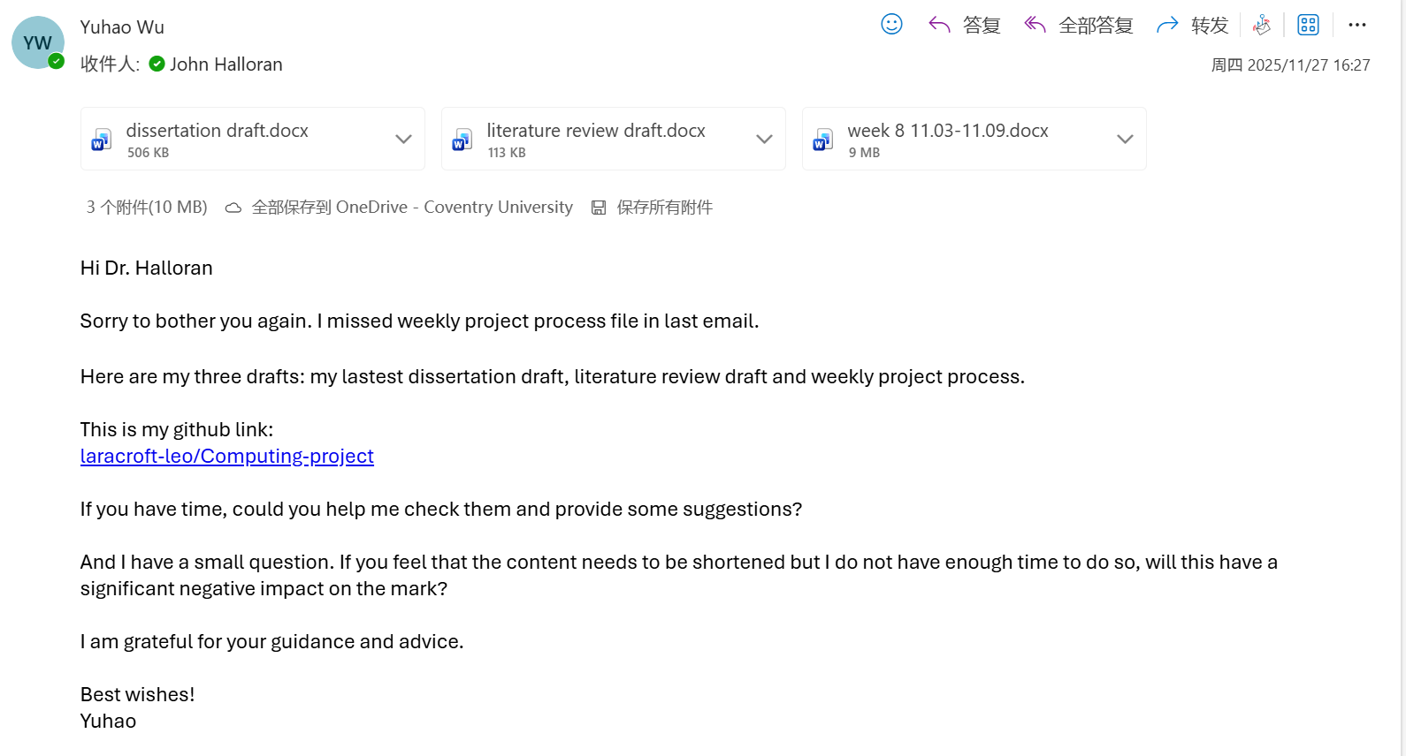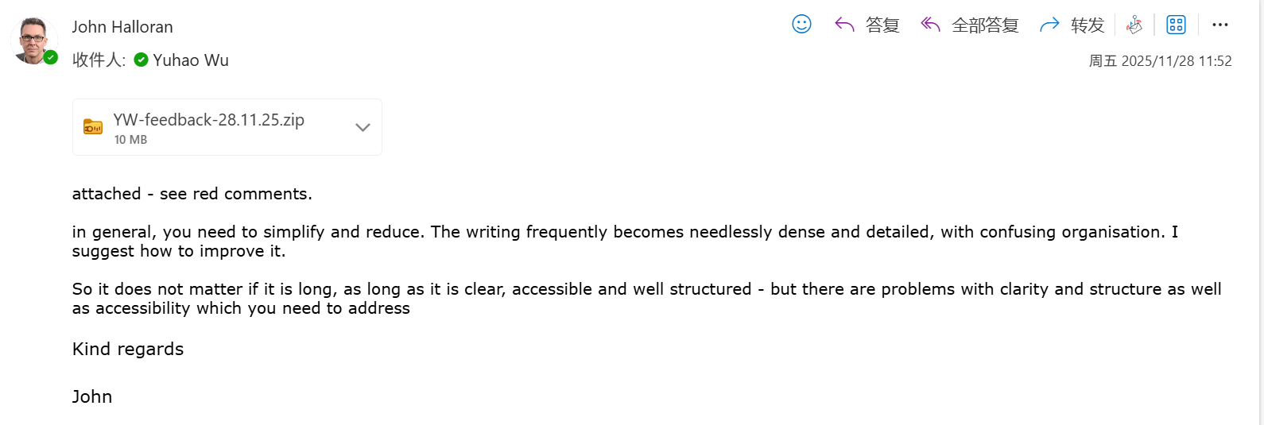

Computing Project
WORK DONE
- Literature review
- Weekly project process
- Revised and condensed parts of the document based on supervisor feedback.

Issues and challenges
1. There are many problems with the literature review, such as the heading hierarchy and overall organisation.
2. The project process needs to be simplified.
3. The dissertation title is confusing, and some parts are not clear enough.

Actions for next week
- Finish the dissertation and prepare the presentation.
- Continued revising and condensing the remaining document sections based on the supervisor’s feedback.

Link to recording
Part 1
https://livecoventryac-my.sharepoint.com/:v:/g/personal/wuy176_uni_coventry_ac_uk/IQC5GkxwLGsORJNE-1sB_yfDAYEm9NSPVNLX4-IrbiDJyik?nav=eyJyZWZlcnJhbEluZm8iOnsicmVmZXJyYWxBcHAiOiJTdHJlYW1XZWJBcHAiLCJyZWZlcnJhbFZpZXciOiJTaGFyZURpYWxvZy1MaW5rIiwicmVmZXJyYWxBcHBQbGF0Zm9ybSI6IldlYiIsInJlZmVycmFsTW9kZSI6InZpZXcifX0%3D&e=V4Cnqg

Part 2
https://livecoventryac-my.sharepoint.com/:v:/g/personal/wuy176_uni_coventry_ac_uk/IQD6XBhccrLET6GeM-yy0YCQAdF8HyLNOxYl_rH7FBSreuA?nav=eyJyZWZlcnJhbEluZm8iOnsicmVmZXJyYWxBcHAiOiJTdHJlYW1XZWJBcHAiLCJyZWZlcnJhbFZpZXciOiJTaGFyZURpYWxvZy1MaW5rIiwicmVmZXJyYWxBcHBQbGF0Zm9ybSI6IldlYiIsInJlZmVycmFsTW9kZSI6InZpZXcifX0%3D&e=UQDQqS

